**FROM:** HENRY MARRAH

**ID NO:** 19290308

**LEVEL:** THIRD YEAR, FIRST SEMESTER

**TO:** MR. DANIEL

T**OPIC**: With steps and guides given below, write an instruction manual on :

A troubleshooting guide and installation guides of a renowned software to your co-workers.

**User manual guide for installing Turbo c in your PC**

**Steps to follows for installation:**

* In order to install the Turbo C IDE as well as the MinGW compiler, you must download it first. Download the setup file and save it in you C Drive.
* After the download completes, extract all the contents of the ZIP file into “*C:\TC*“. It should look like this after extraction.

[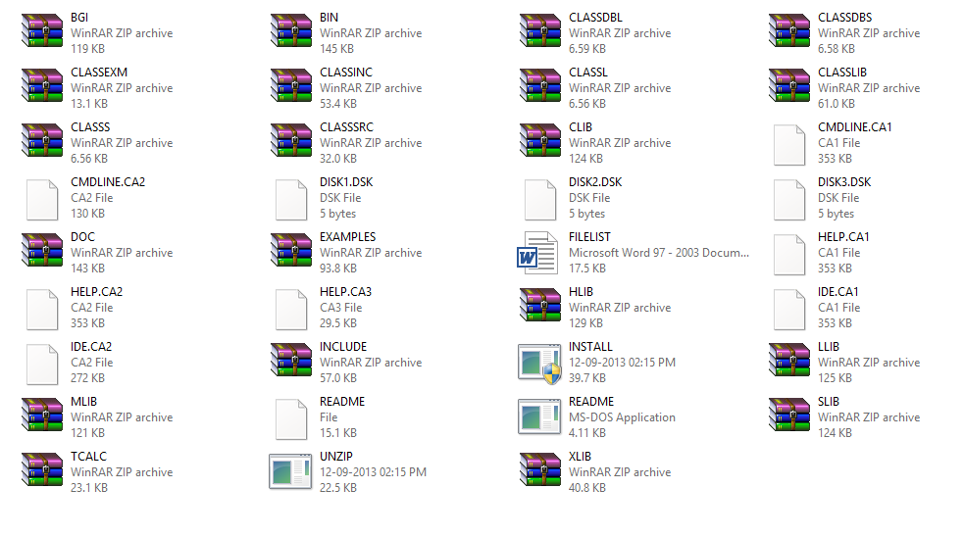](https://www.slashcoding.com/wp-content/uploads/2013/09/TC3_Extracted.png)

* Open the Turbo C file and double click to the setup file, you see a welcoming note and click<<Next>.
* Run the setup and install DOSBox on your computer. Some Windows 8 installations might say that this application is not compatible with Windows 8, but click on Install anyways because it is completely compatible with Windows.
* Now open up DOSBox from the shortcut on your desktop or from the Start Menu. You should be shown with the following screen and Type in the following lines one by one and hit Enter/Return after every line.  
  mount c: c:\  
  c:  
  cd tc  
  install

[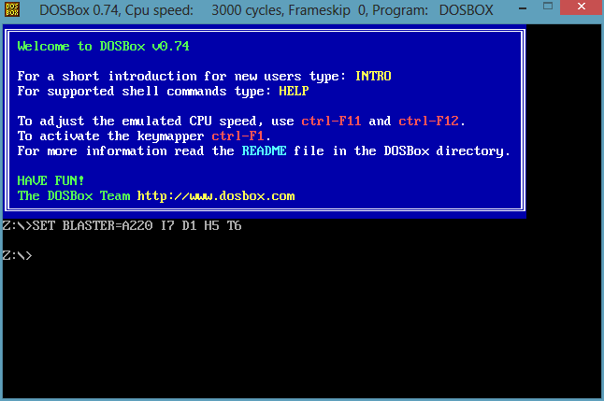](https://www.slashcoding.com/wp-content/uploads/2013/09/DOSBox_Screenshot.png)

* Now you should be presented with the setup for Tubro C++. Press Enter to Continue and enter the Drive Source Letter and
* Press enter. Leave the next setting as it is and press enter.
* Scroll down to Start Installation using arrow keys and press enter, you should be shown with the following screen.

[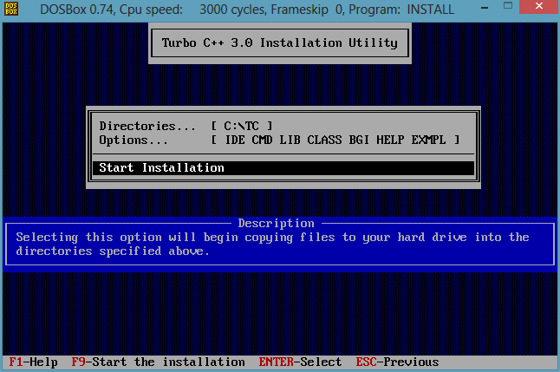](https://www.slashcoding.com/wp-content/uploads/2013/09/TurboC_Install-2.png)

* Now just wait for the installation to finish. After the installation completes, you will be back on the main DOSBox screen. At this stage, close DOSBox by typing in “*exit*” or by clicking the cross (X) button on the top.

**User guide for troubleshoot when the compiler is installed, but Code::Blocks can't find it.**

**Steps to follow:**

* Use the Code::Blocks auto-detect feature to find the compiler
* On the Code::Blocks menu, go to "Settings", next click on "Compiler and Debugger..." This will open the "Compiler and debugger settings dialog".
* Under "Selected compiler" select the name of the compiler you are using. For most of you it will be "GNU GCC Compiler".
* Click on the tab that says "Toolchain executables", then click the button "Auto-detect". This should cause the compiler's installation directory to be automatically inserted into the text box to the left of the button.
* Manually enter the path to the compiler's installation directory
* On the Code::Blocks menu, go to "Settings", next click on "Compiler and Debugger...". This will open the "Compiler and debugger settings dialog".
* Under "Selected compiler" select the name of the compiler you are using. For most of you it will be "GNU GCC Compiler".
* Click on the tab that says "Toolchain executables", then type in the path to the compiler's installation directory in the text box labeld "Compiler's installation directory".
* Be sure the names of all the executables are entered in the spaces listed under "Program Files".
* The screen shot below shows the default compiler and debugger settings if you installed Code::Blocks with the setup program that includes MinGW. These settings are the same on Windows XP, Vista, and Windows 7. (I've personally installed and tested Code::Blocks on 32 bit versions of each Windows OS and the 64 bit version of Windows 7.)